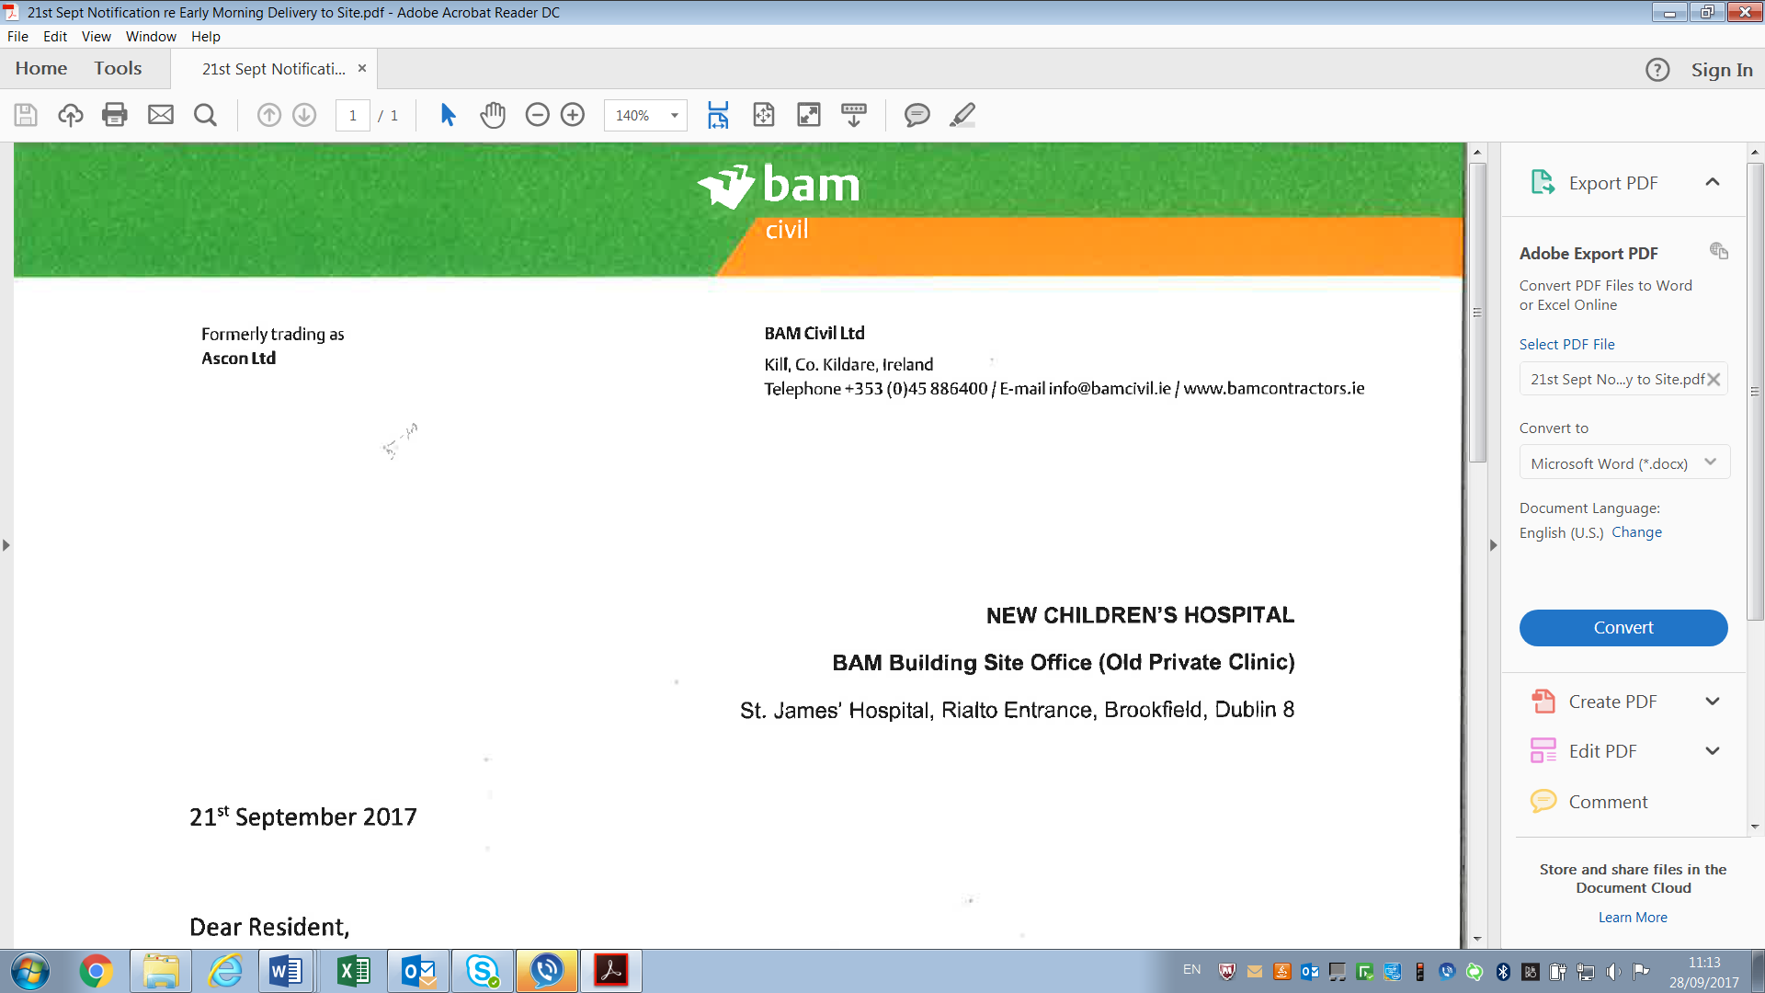

**NEW CHILDREN’S HOSPITAL**

**BAM Building Site Office (Old Private Clinic)**

St. James’ Hospital, Rialto Entrance, Brookfield, Dublin 8

13th October 2017

**Information on works due to take place to the rear of Cameron Square**

Dear Resident,

As you may know, piling activity has been taking place at several locations within the new children’s hospital site. Towards the end of October 2017 similar piling will commence to the east of Cameron Square.

The piling machine will be located close to the hoarding which is already to the rear of houses 23 – 31 Cameron Square. In advance of piling commencing, dust, noise, vibration and movement monitors will be in place. As you will know from recent contacts and communications, most of your houses have been installed with prisms on exterior walls which will be monitored by Automatic Monitoring Stations (AMS’s) located on site. ‘Tell-tale’ monitors have also been installed on some properties to monitor existing cracks.

Before piling commences we thought it prudent to provide you with some information on what is involved during the various stages of the piling process. The image below shows the various stages involved, what a piling machine looks like and the site walls created:





BASEMENT WALLS ARE FORMED USING SECANT PILES

A MAJOR ADVANTAGES OF THIS METHOD IS THAT IT IS LESS NOISY THAT OTHER PILING

Step 1 – Property Surveys and Environmental Monitor

The method of piling that is being used is less noisy than many others and does not involve disturbing ground, other than at the drill position. Before we start this work we will be installing monitoring equipment that records noise levels, vibration and ground movement. This live monitoring equipment will be in place for the duration of the works and monitors the environmental conditions. This ensures that we are aware of the levels at any given time and can address any elevated levels which is notified to us automatically. In addition we will take records of the existing conditions of nearby property.

Step 2 - Installation of new hoarding support posts

The existing supports to our hoarding are being replaced to make way for future excavation. New support post and foundations will be installed before the existing support posts are removed. This will involve the excavation of foundations for the posts and concreting the new supports in place. All of this work is on the construction side of the hoarding, the hoarding will not be moved or changed during this process.

Step 3 - Creating a piling platform

The ground behind our hoarding will be lowered by excavator and a piling platform (crushed stone) will be placed, this provides a level working area. As this work is taking place we will start building guidewalls for piling. The guidewall is a concrete slab that has holes in it at the location of each pile, it ensures the piles go in the correct position. This process will happen in phases as we work our way along the boundary.

Step 4 - Piling

When there is enough piling platform and guidewall constructed, we will start piling. The process involves a corkscrew drill that removes the clay and when it has reached the bottom, concrete is pumped into the hole as the drill is withdrawn. The piled wall is made of two types of pile, a firm pile and a hard pile, which interlock with each other. The firm pile is drilled in first, at every other pile location, then the hole for the hard pile is drilled in between, filled with concrete and reinforcement.

Step 5 – Capping Beam

When a section of piling has been installed we will build a capping beam (large concrete beam) at the top of the piles that locks all of the piles together. The top of the beam is around the same level as the existing ground. We can then fill back up the excavation at the rear of the hoarding. When all concrete has cured, we start excavation for the basement.

Any piling to take place in the vicinity to the rear (south) of 31-41 Cameron Square will not take place until early 2018. The private clinic has first to be demolished, notice will be given to residents in advance of this demolition taking place.

In November 2016 a Resident Project Monitoring Committee was formed with local residents, local councillors and Dublin City Council and commenced a process of employing an independent technical advisor to provide independent technical advice to residents in relation to technical queries or interpretation of information they may have. Should you have any technical enquiries in relation to the piling, please do not hesitate to contact the team at Atkins at 01 8108000 / [info.ie@atkinsglobal.com](mailto:info.ie@atkinsglobal.com).

Yours sincerely,

Garry Keegan

Bam Community Liaison